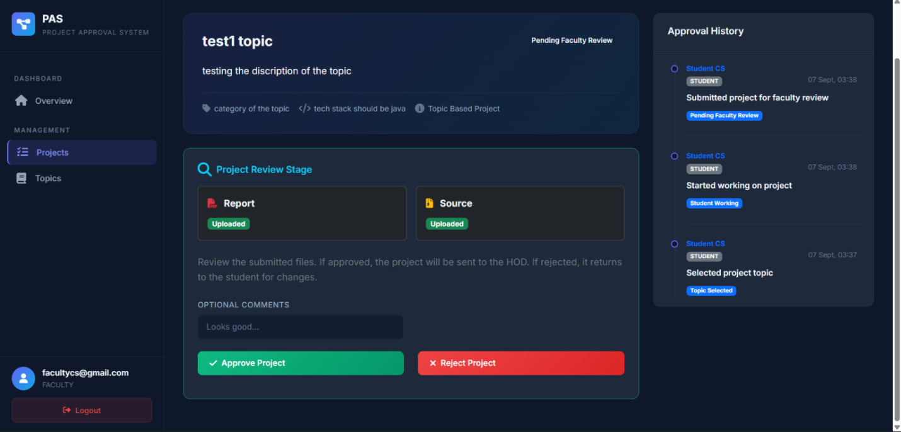

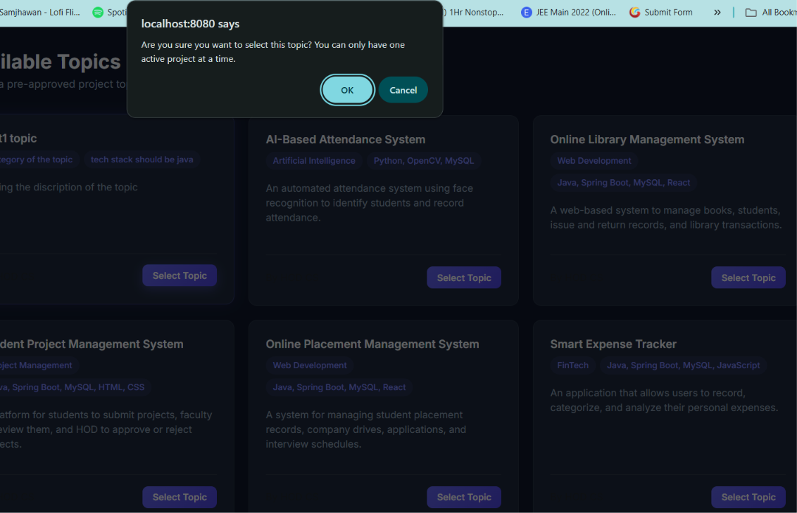
Faculty can not see the report and source code uploaded by the student in the project review stage

Why this thing is coming when we are selecting the topic ..??
There should come pop up type some thing saying this
Why this thing is coming in the pop up and how to fix it 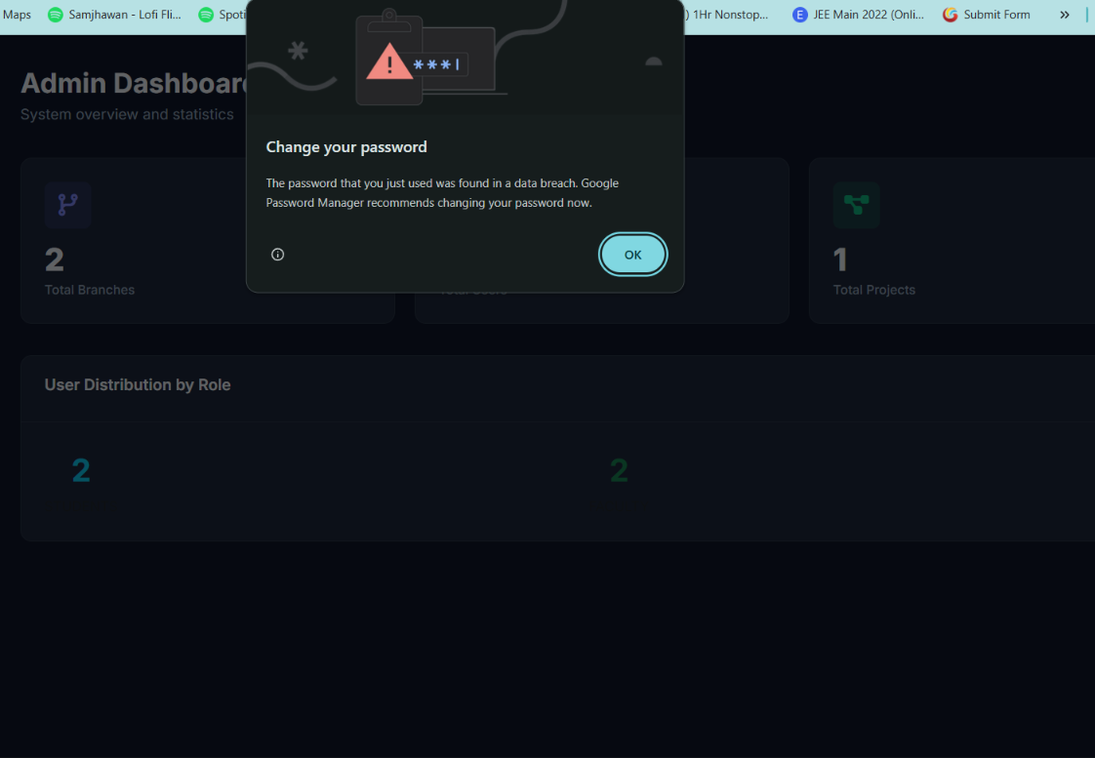

Faculty can not see the report and source code uploaded by the student in the project review stage

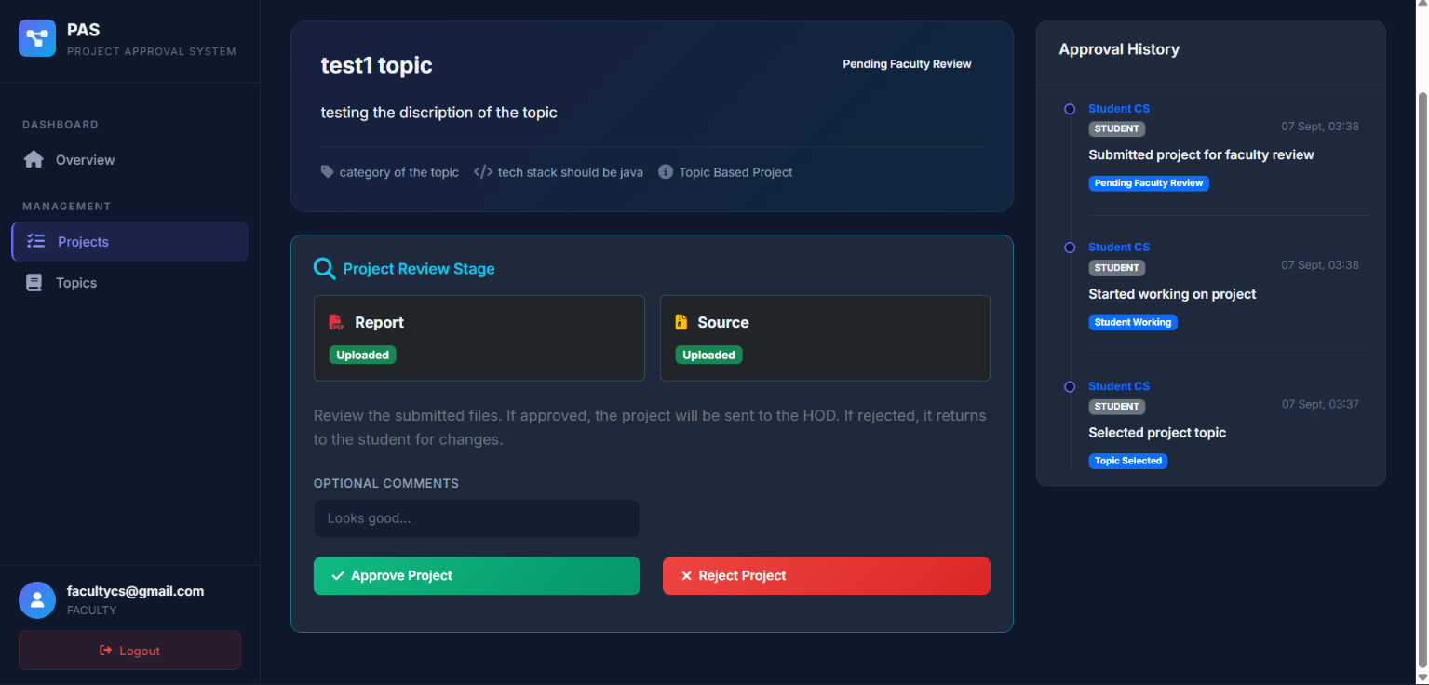
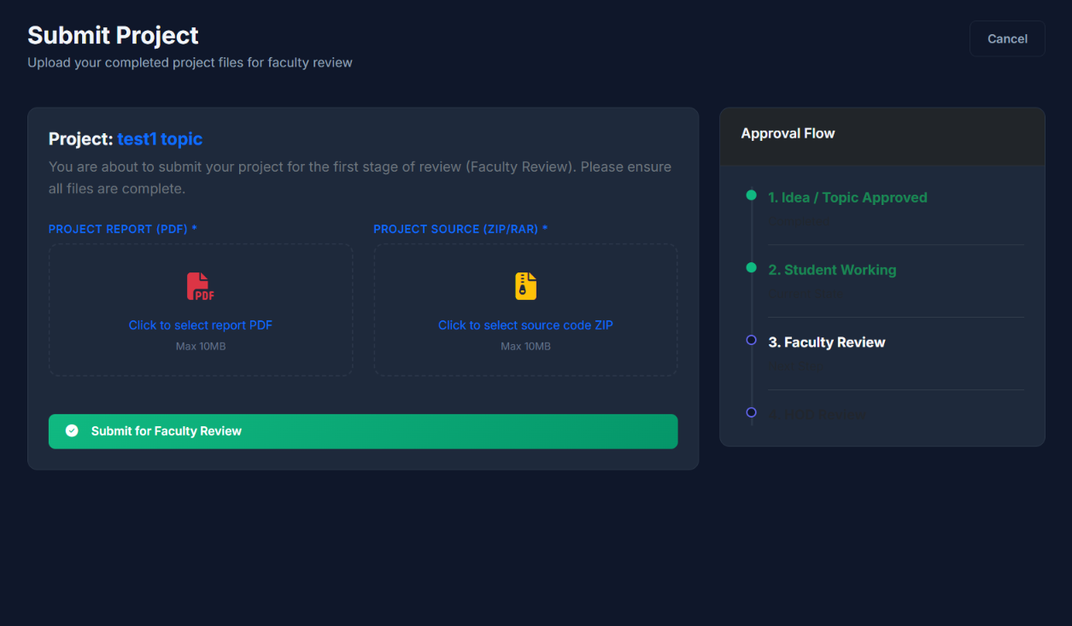
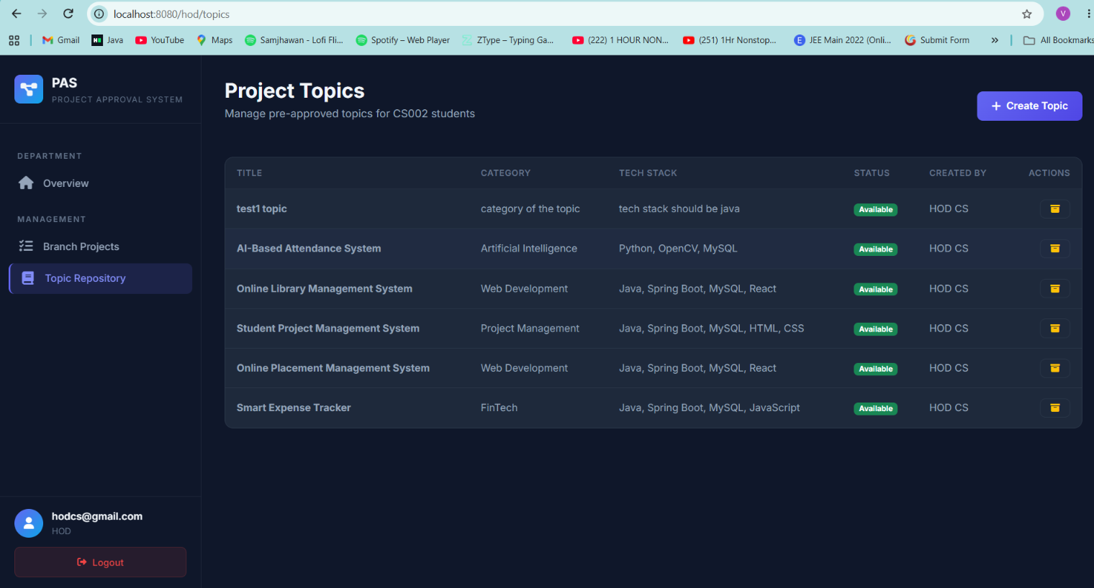
In the project topic there should be a function where I can edit the topic ditales only till the time status is showing available
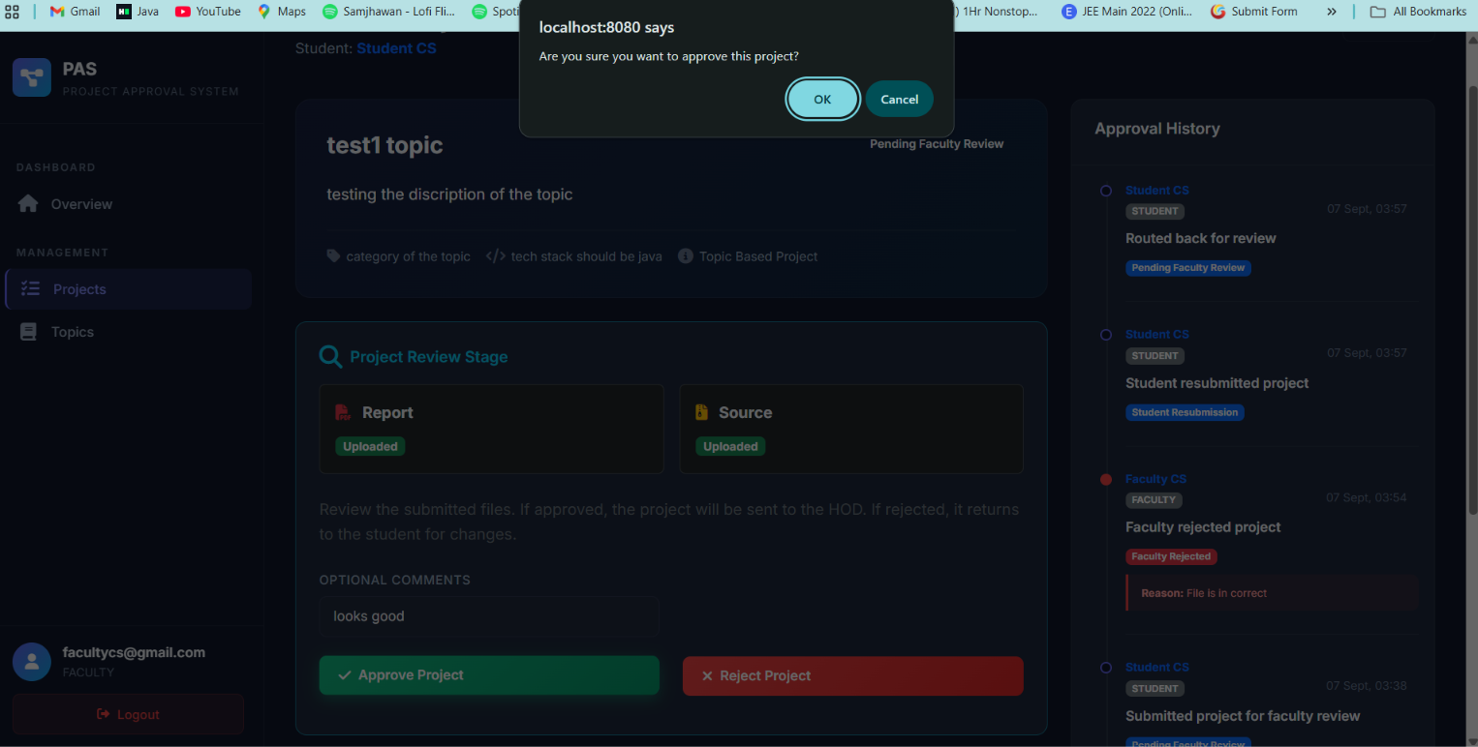

Pop up should come naa
The form will be circulated by the hod for chosing the guide for there project
Form contain ----
Faculty name , branch name ,avalibility , no. of sudent a faculty can guide to
if the faculty has the max student and the vacancy is full then the student left will get random faculty as there guide
Student will select there faculty they want to make the guide and will work on the project under them the submition of the project topic or the proposed topic will go to the selected faculty that a student has made the guide
/////////////////////////////////////////////////////////
Not done yet
///////////////////////////
Student can delete the project till the time faculty did not sees it or you can say did nto took any action at that time

